Parameter: Source document
Purchase order with 50 EUR freight costs (allocation charge) posted with business unit 20.
The customer account is setup with business unit 10
On the liability summary account (200100) only one single posting is created with business unit 10
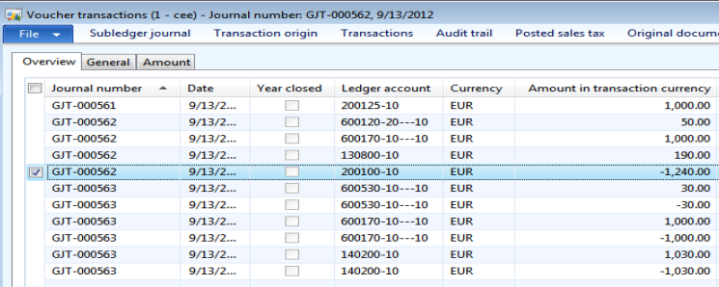
Parameter: Accounting distributions
Same posting as before but AX splits now the posting on the liability summary account:
50 EUR are posted with business unit 20 (from the distribution) and the rest is posted with business unit 10
