- Open CommandPromt in Administrator Mode :
Run below Command to set root path :
cd "C:\Program Files (x86)\Microsoft Dynamics 365 Business Central\130\RoleTailored Client"
- Convert Old Table objects(C/AL Code) to New Table Objects in AL Code :

- We have not modified any base tables so just create a baseTableObjects.txt file manually with empty value.
C:\Users\surajit\Desktop\Surajit\NAVCloud\baseTableObjects.txt.
- Create txt file of New TableObjects using below command in CommandPromt:
finsql.exe Command=ExportToNewSyntax, file="C:\Users\surajit\Desktop\Surajit\NAVCloud\customTableObjects.txt", Database="surajit", ServerName="TEST-BC\NAVDEMO" ,filter="Type=table;ID=33064461| 33064462|33064463|33064464|33064465|33064466|33064467|33064468|33064469|33064470|33064471|33064472|33064473|33064474|33064475|33064476|33064477|33064478|33064479|33064480|33064481|33064482|33064483| 33064484|33064485|33064485|33064486|33064487"
Note : Export .txt file will be not generated If you don’t have valid license .To check the valid error
- Open PowwerShell Command and Run below Command :
Import-Module 'C:\Program Files (x86)\Microsoft Dynamics 365 Business Central\130\RoleTailored Client\NavModelTools.ps1'
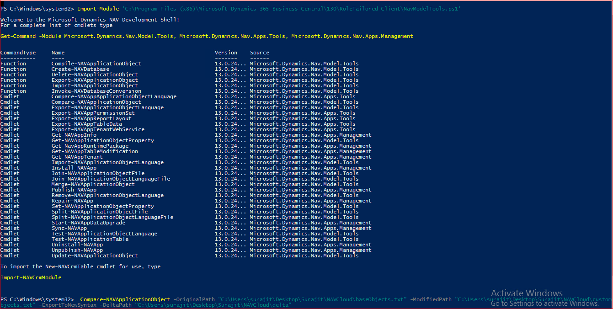

- Create Table Delta File using Below Command in CommandPromt:
Compare-NAVApplicationObject -OriginalPath "C:\Users\surajit\Desktop\Surajit\NAVCloud\baseTableObjects.txt" -ModifiedPath "C:\Users\surajit\Desktop\Surajit\NAVCloud\customTableObjects.txt" -ExportToNewSyntax -DeltaPath "C:\Users\surajit\Desktop\Surajit\NAVCloud\Delta Files\Tables"

- Create Table Al File using below command in CommandPromt :
txt2al.exe --source="C:\Users\surajit\Desktop\Surajit\NAVCloud\Delta Files\Tables" --target="C:\Users\surajit\Desktop\Surajit\NAVCloud\AL Files\Tables" ExtensionStartId=33064461

- Convert Old Page objects(C/AL Code) to New Page Objects in AL Code :

- Base pages export to a text file which will be modified by our extension .Run below command in CommandPromt :
finsql.exe Command=ExportToNewSyntax, File="C:\Users\surajit\Desktop\Surajit\NAVCloud\basePageObjects.txt", Database="BC130", ServerName="TEST-BC\NAVDEMO" ,filter="Type=page;ID=21|30|300|42|5050|5056"

- Modified Base pages export to a text file which are modified by our extension .Run below command in CommandPromt :

finsql.exe Command=ExportToNewSyntax, File="C:\Users\surajit\Desktop\Surajit\NAVCloud\customPageObjects.txt", Database="surajit", ServerName="TEST-BC\NAVDEMO" ,filter="Type=page;ID=21|30|42|300|5050|5056|33064461|33064462|33064463|33064464|33064465|33064466|33064467|33064468|33064469|33064470|33064471|33064472|33064473|33064474|33064475|33064476|33064477|33064478|33064479|33064480|33064481|33064482|33064483|33064484|33064485|33064485|33064486|33064487|33064488|33064489|33064490|33064491|33064500"

- Open PowwerShell Command > Create delta files from page objects .txt file:
Compare-NAVApplicationObject -OriginalPath "C:\Users\surajit\Desktop\Surajit\NAVCloud\basePageObjects.txt" -ModifiedPath "C:\Users\surajit\Desktop\Surajit\NAVCloud\customPageObjects.txt" -ExportToNewSyntax -DeltaPath "C:\Users\surajit\Desktop\Surajit\NAVCloud\Delta Files\Pages"

- Create Page Al Files using below command in CommandPromt :
txt2al.exe --source="C:\Users\surajit\Desktop\Surajit\NAVCloud\Delta Files\Pages" --target="C:\Users\surajit\Desktop\Surajit\NAVCloud\AL Files\Pages" ExtensionStartId=33064461
How to create package file from Converted AL files :

