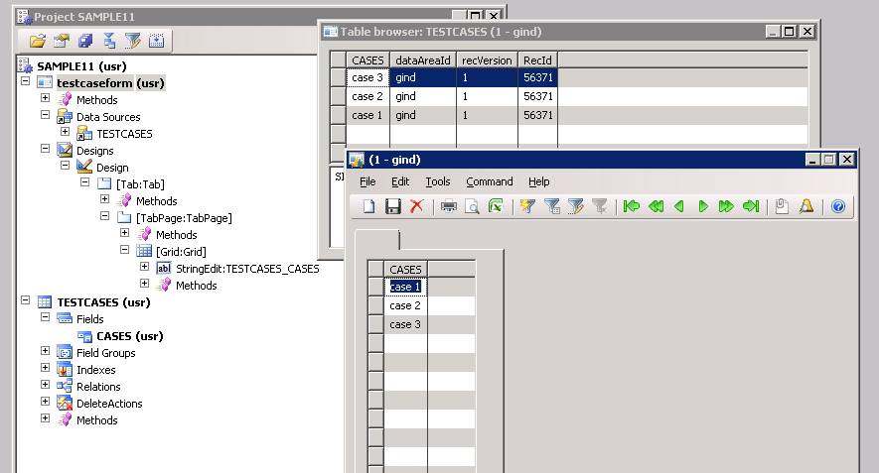
See the test case table has only one field and my testcase form has 3 entries......in my main form i shold get all the 3 entries as shown below.

