My requiments is I want to add a new field in packing slip field name is REMARKS…….
Here I show the highlighted button name posting in left side . if I click packing slip in this button ….?
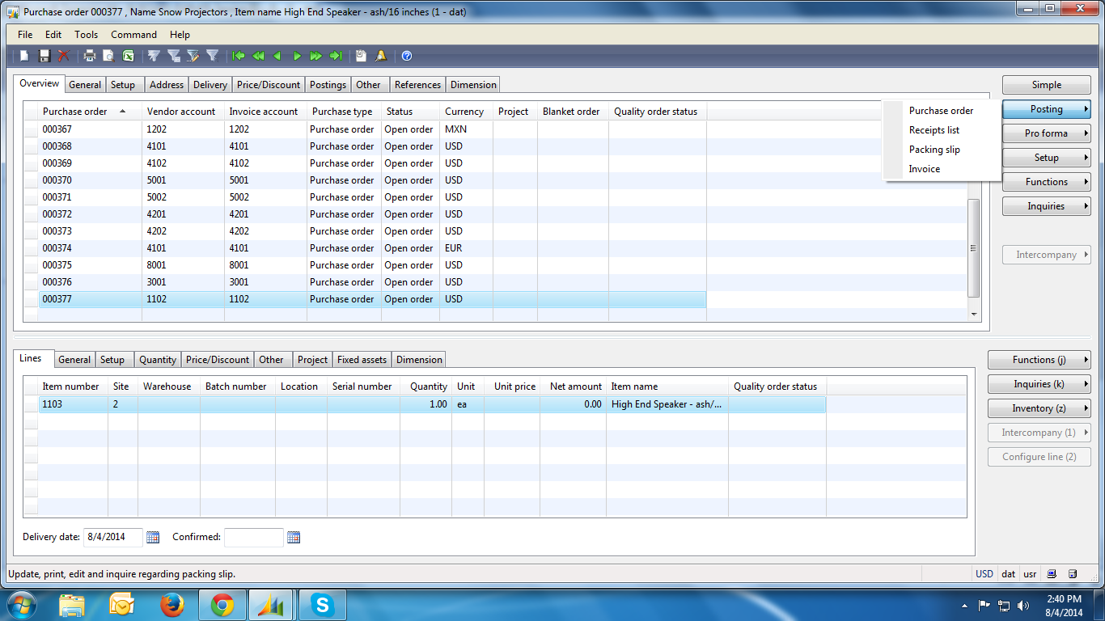

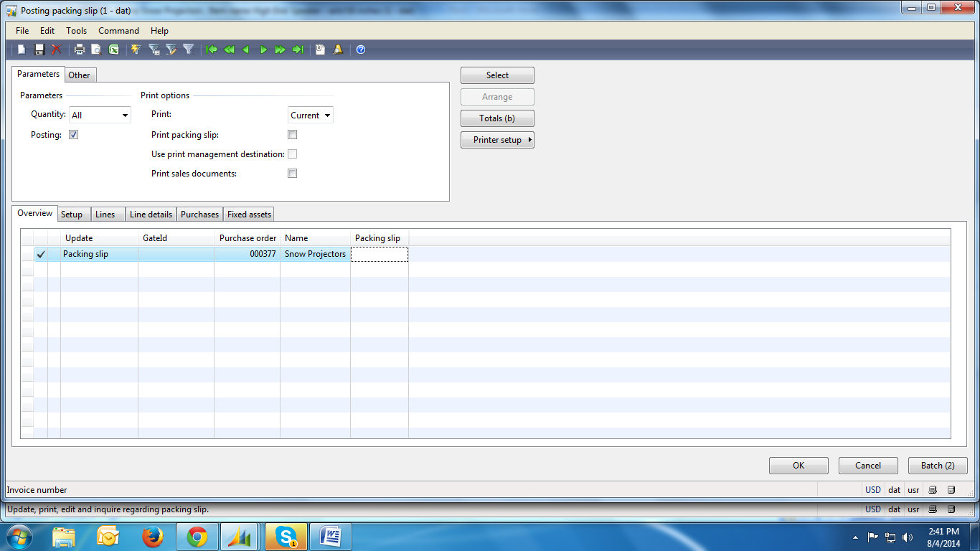
In above picture I show u the process behind after I click packing slip in posting button..
In this picture below in lines field name REMARKS is apper next to packing slip ..
Once I enter values in that field REMARKS it updated in packing slip form automatically .
For this wat will I do ??

After save the values in field REMARKS I move to inquiries in that I choose packing slip
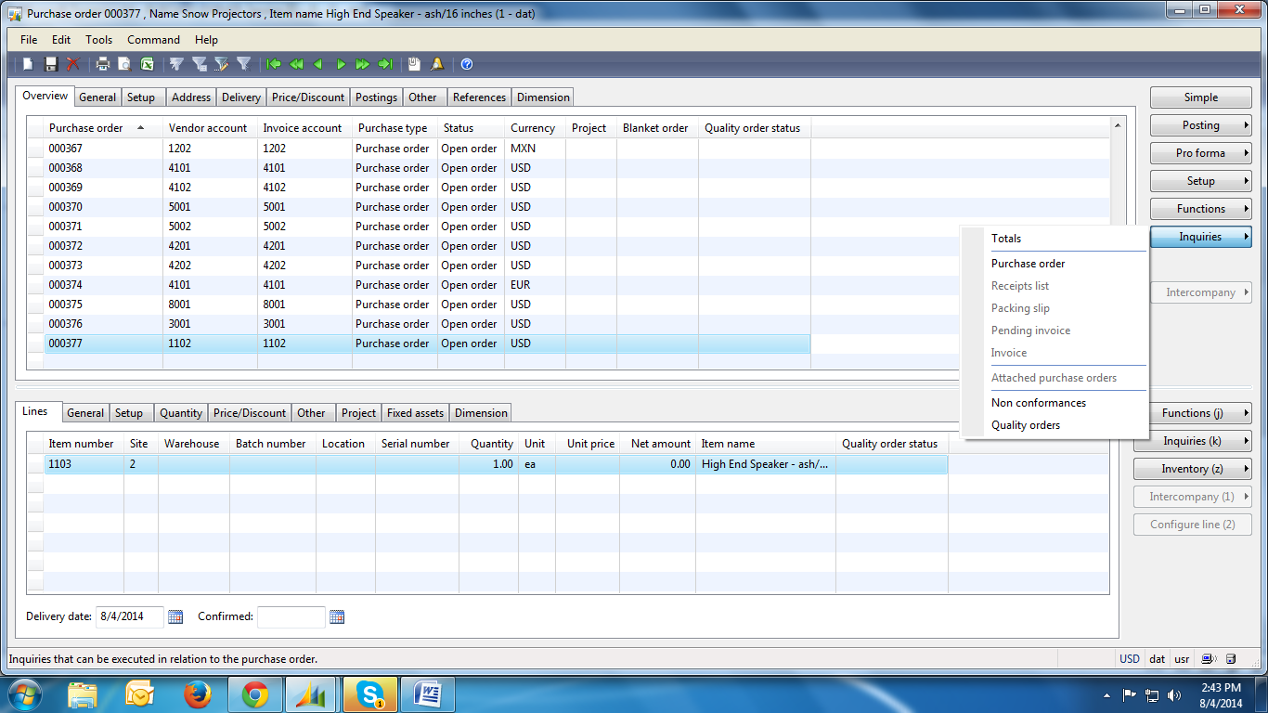

In packing slip I want like this below fields all having details as like I want in REMARKS will updated the values which I entered in lines .
