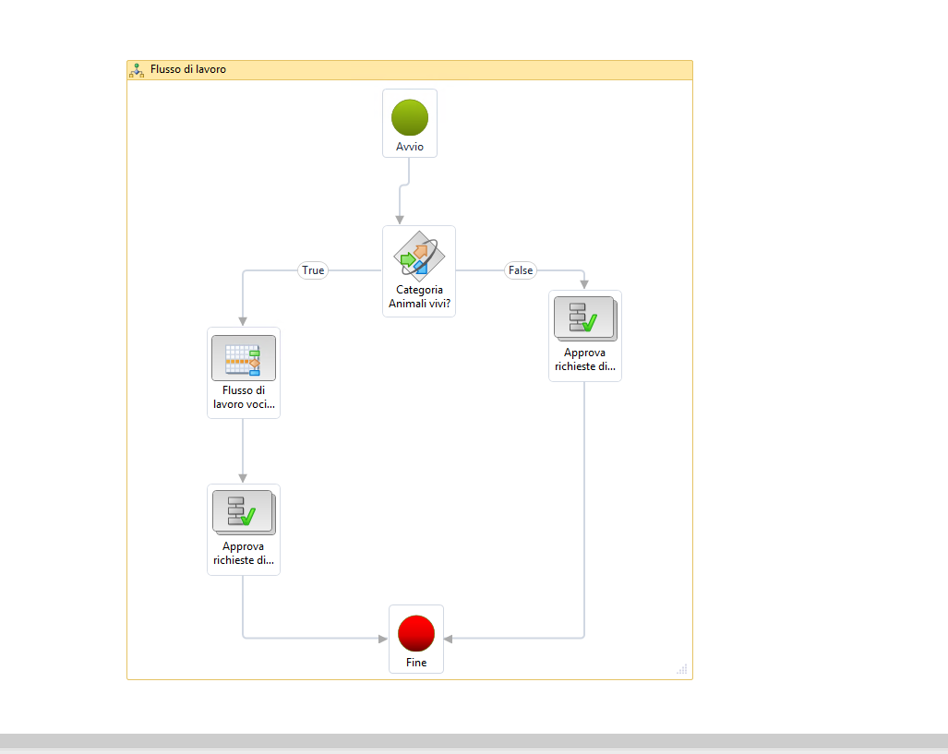

Approve PR automatically if all lines belong to the “automatic category”

Approve PR lines, if the lines belong to the automatic category and not.

Line item workflow “purchase requistion lines” with the same automatic condition on the category

Approve PR manually

Is the procurement category “live animals” ?