Concept
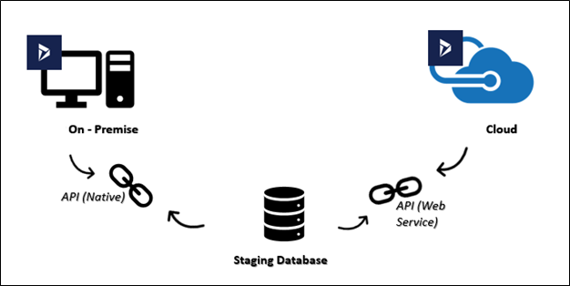

- There are two D365 environment: On-premise and Cloud
- The idea is to integrate both environment without exposing On-premise to external network
- Staging database will be used to temporarily hold data from one environment to be retrieved by the other environment
- Records to be synchronized are: Product master, sales order, order posting status, stocks consumption

Technologies to be used
Technology to be used is any of the following:
- Custom Service (SOAP)
- Custom Service (JSON)
- OData Integration

Procedures
I have configured the following as per D365 Dynamics Cookbook and https://docs.microsoft.com/en-us/dynamics365/unified-operations/dev-itpro/data-entities/services-home-page :
- App Registration from the AAD
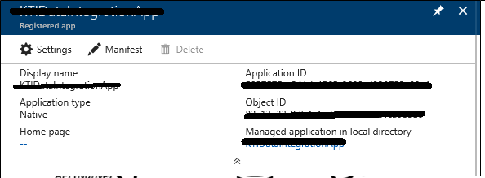
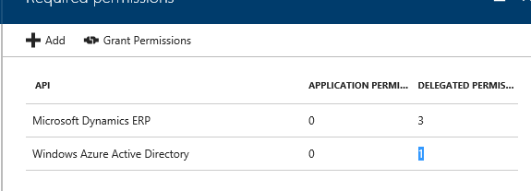
- Azure Active Directory applications from D365O
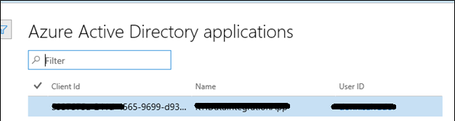

Authentication Code
Followed the code from D365 Development Cookbook and Github.

Authentication
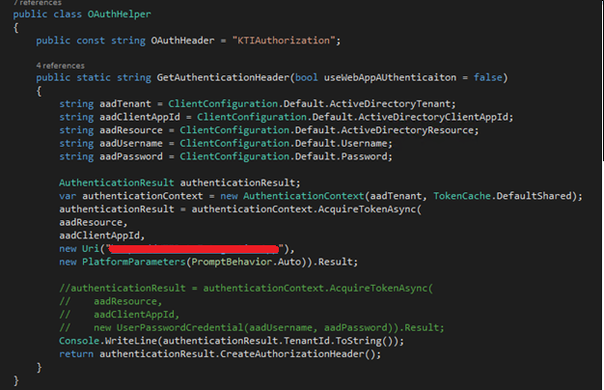

Client Configuration
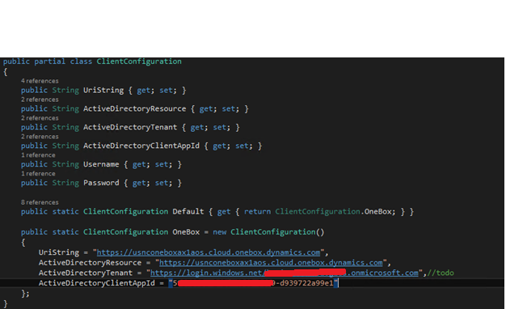

Authentication Testing
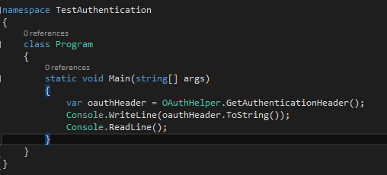

Sample Output
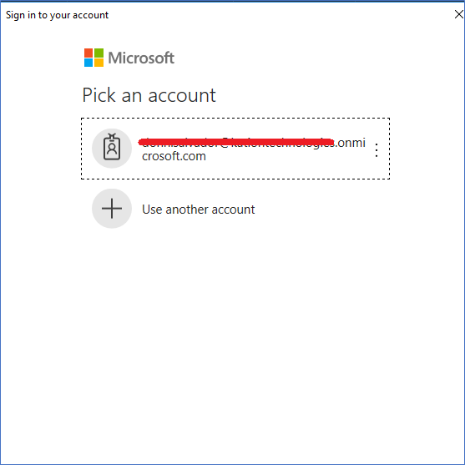

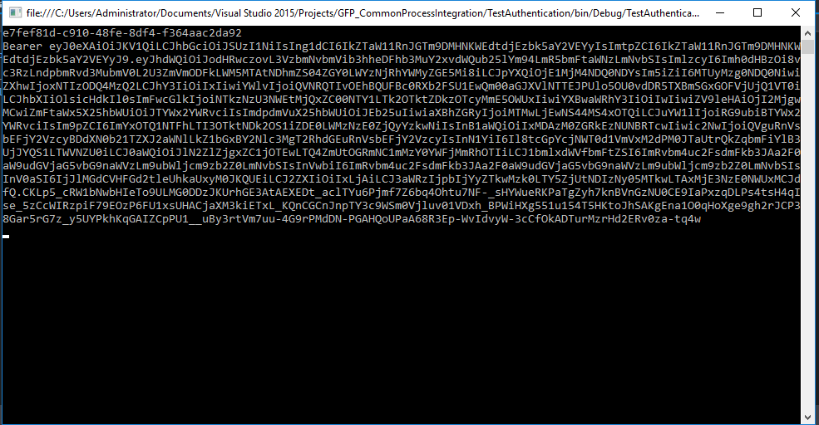

Integration Code

SOAP
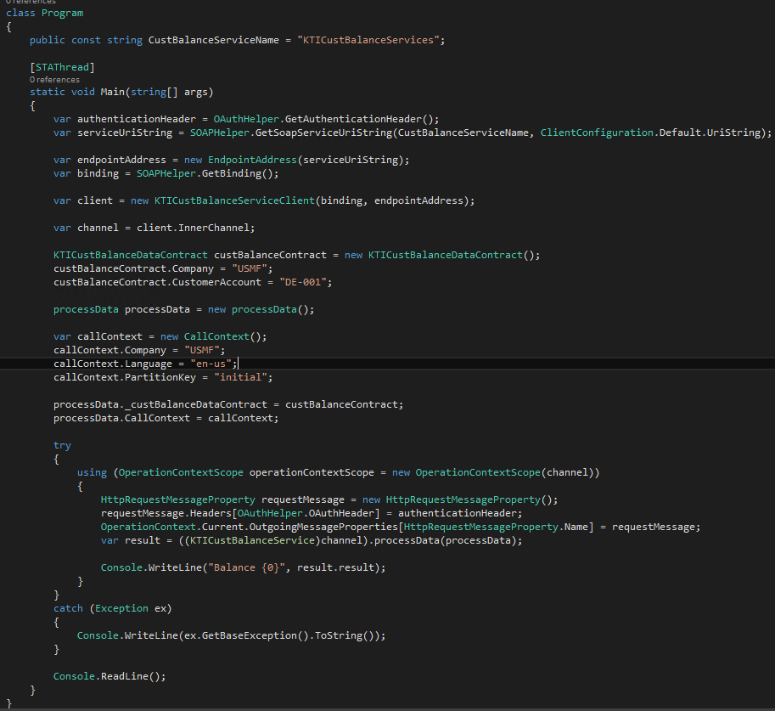

JSON
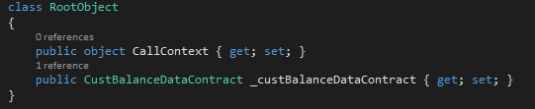
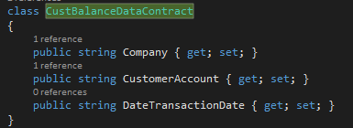

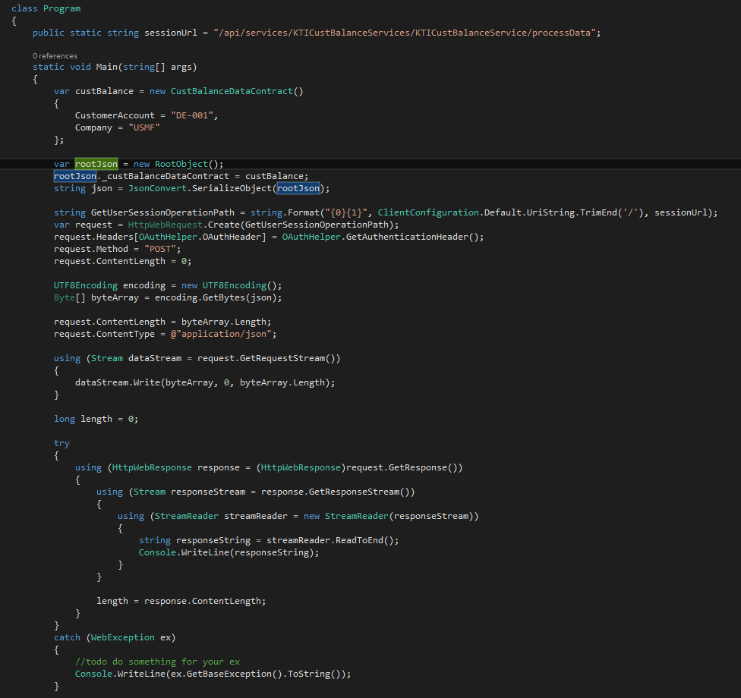

ODATA
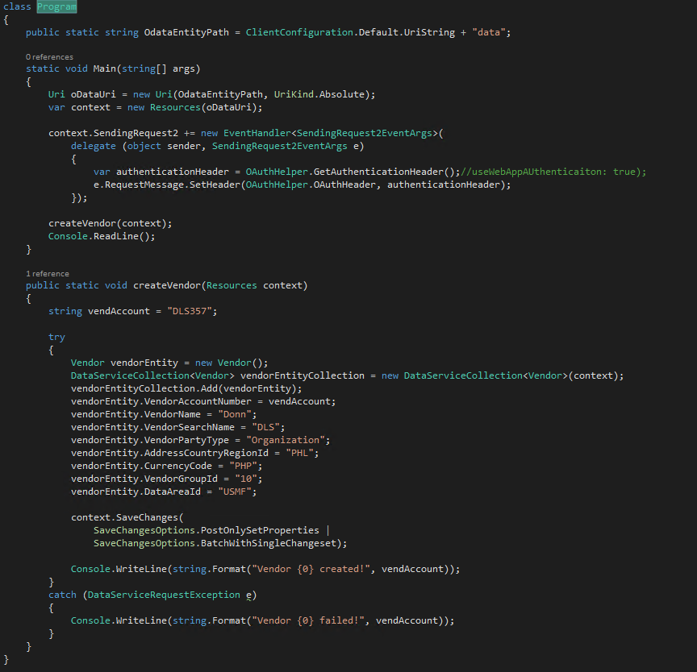

Error

SOAP
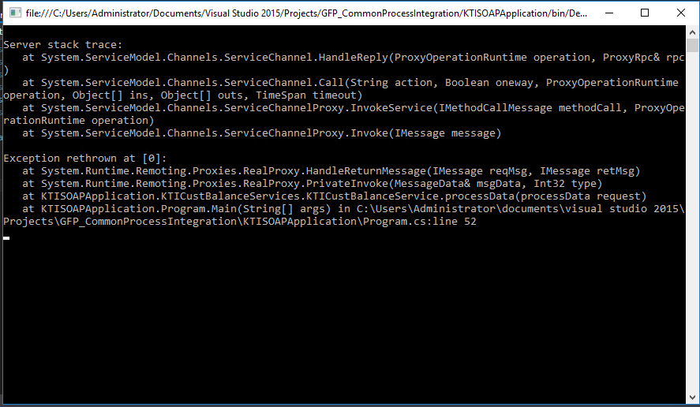
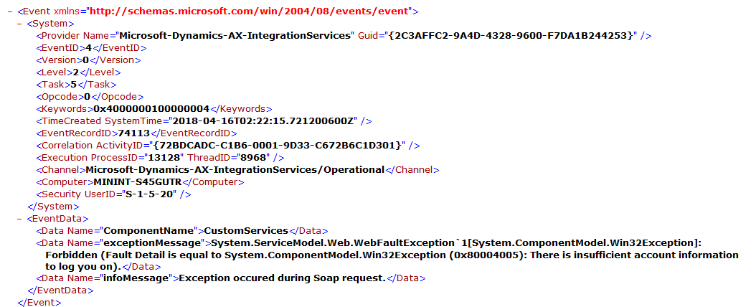

JSON
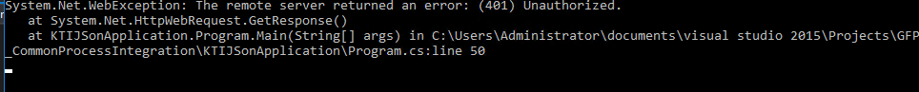
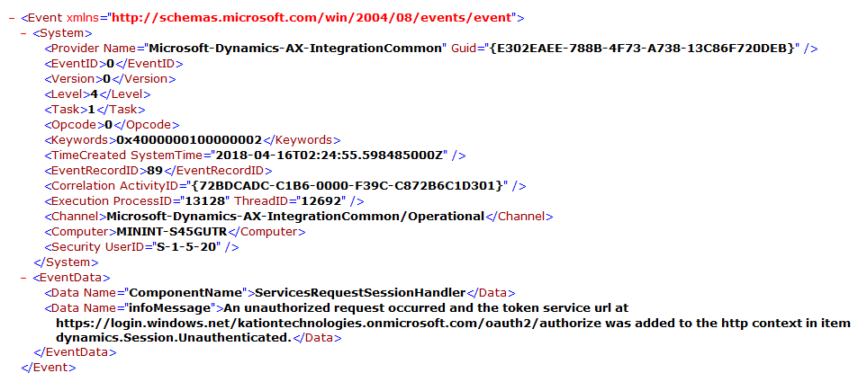

ODATA
