Bank Account Reconciliation: Filter Bank Account Ledger Entries Based on Statement Date
Objects to be modified
- Table 273: Bank Acc. Reconciliation
- Page 379: Bank Acc. Reconciliation

Modify table 273 as shown below
Add a new Field Name – “Statement Date Filter”, Data Type – “Text”, Length – “30”
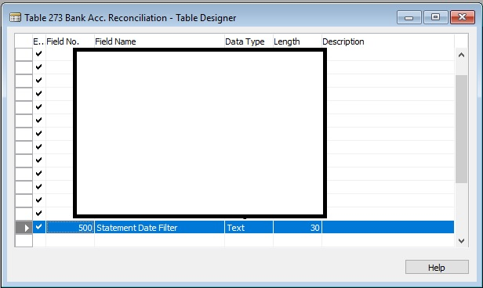

Modify page 379 C/AL code as shown below
On the OnValidate Trigger of field control “StatementDate” add the code as shown below
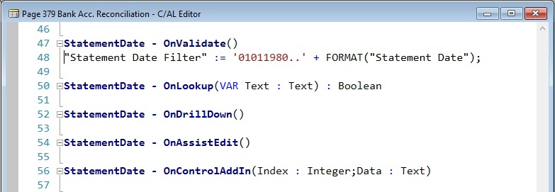

Modify page 379 Page Designer as shown below
Highlight the Part page named “ApplyBankLedgerEntries” (1)
On the SubPageLink line on the property window, press the eclipse button for the table filter page (2)
Add a new line on the table filter page as indicated below (3)
